Description: H:\Graphicriver\print templates\Level 7\Resume 4\png\10.png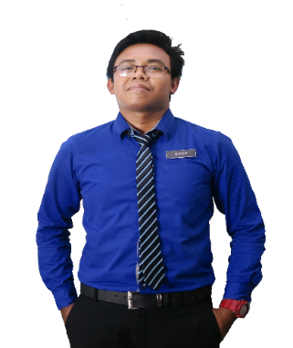

Teach at undergraduate and graduate level in areas allocated by the Head of Department and reviewed from time to time by the Head of Department. Carry out research and produce publications, or other research outputs, in line with personal objectives agreed in the Staff review process.

2008 - 2011

**LECTURER**

**WORK EXPERIENCES**

UNIVERSITI TEKNOLOGI MARA, KAMPUS PUNCAK ALAM



MUHD

SOLEH

**TEACHER**

SEKOLAH MENENGAH KEBANGSAAN SUNGAI BULOH

2008 - 2011

Implements curriculum objectives and goals using effective teaching techniques and materials. Develops, in a cooperative manner with the principal and curriculum facilitators, a plan for the improvement and enrichment of instruction.

MUHAMAD SOLEH HUDIN BIN SHAMSUDDIN

Description: H:\Graphicriver\print templates\Level 7\Resume 4\png\11.png

**EDUCATION**

Description: H:\Graphicriver\print templates\Level 7\Resume 4\png\2.png

**PROFILE**

2008 - 2011

**UNIVERSITI TEKNOLOGI MARA SHAH ALAM**

As a future educator, I will be creating knowledgeable leaders who have the ability to take their own decisions and rise with their community. I believe to be a great teacher, connections need to be made with students’, support needs to be given and passionate teaching should be seen through the student eyes.

**UNIVERSITI TEKNOLOGI MARA PUNCAK ALAM**

2008 - 2011

Master in Science

Bachelor of Education in Science (Hons) Chemistry

2008 - 2011

Sijil Pelajaran Malaysia (SPM)

**SEKOLAH MEN KEB JELAI**

2008 - 2011

Science Stream (Module II)

**KOLEJ MATRIKULASI KEDAH, CHANGLUN**



**CONTACT**

Description: H:\Graphicriver\print templates\Level 7\Resume 4\png\11.pngDescription: H:\Graphicriver\print templates\Level 7\Resume 4\png\3.png

**ACHIEVEMENTS**

Description: H:\Graphicriver\print templates\Level 7\Resume 4\png\4.png

+6013-2805916

2

resumecreative@yahoo.com

* Graphic Design Award 2015, Kuala Lumpur
* Anugerah Guru Cemerlang SMK Bandar Baru Sungai Buloh 2016
* Larian Hari Sukan Negara 2016, UiTM Kampus Puncak Alam
* Volunteer for SUKMA 18, Pahang Darul Makmur
* Creative and Innovation Awards 2017
* Anugerah Perkhidmatan Cemerlang 2017, SMK Kuala Tekal
* Innovation and Creative Product Competition 2015

4

Creative Resume, 74000 Bandar Puncak Alam, Selangor

Description: H:\Graphicriver\print templates\Level 7\Resume 4\png\8.png****Description: H:\Graphicriver\print templates\Level 7\Resume 4\png\8.png

**Microsoft Office**

**PERSONAL**

**Teamwork**

**Leadership**

**Communication**

**y**

**Friendliness**

**Illustrator**

**y**

**SKILLS**

**Adobe Photoshop**

**After Effect**

Description: H:\Graphicriver\print templates\Level 7\Resume 4\png\12.png

**REFERENCES**

Fakulti Pendidikan, Universiti Teknologi Mara, Kampus Puncak Alam, Selangor.

**P :** +60132805916  
**E :** furkan@uitm.edu.my

**FURKAN BIN MAT SALLEH**

Academic Advisor

**FURKAN BIN MAT SALLEH**

Academic Advisor

**P :** +60132805916  
**E :** furkan@uitm.edu.my

Fakulti Pendidikan, Universiti Teknologi Mara, Kampus Puncak Alam, Selangor.